Countries and Activities

France
- Christmas traditions of France (click here)
- Nativity Scene:
  - Click here for printable directions
- Map of France
- Flag of France

Germany
- Christmas traditions of Germany (click here)
- Christmas crafts from Germany (Scherenschnitte heart, Weihnacht angel)
- Map of Germany
- Flag of Germany

England
- Christmas traditions of England (click here)
- Christmas crafts from England (Christmas cards, crackers, and pomanders)
- Map of England
- Flag of England

Holland/Netherlands *
- Christmas traditions of Holland (click here)
- Map of Holland
- Flag of Holland

Italy
- Christmas traditions of Italy (click here)
- Map of Italy
- Flag of Italy

Mexico
- Christmas traditions of Mexico (click here)
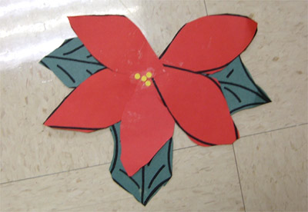
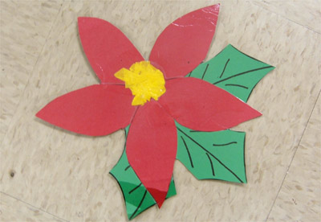
- Printable Poinsettia activities:
  - Printable activities
- Poinsettia Fan craft:
  - Click here for directions
- Cone Cup Pinata:
  - Click here for directions
- Map of Mexico
- Flag of Mexico
- Paper Poinsettias:
  - Printable poinsettia pattern - .pdf format

Israel
- Hanukkah traditions and activities(click here)
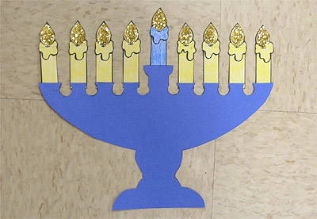
- Hanukkah coloring pages
- Hanukkah Candle:
  - Click here for printable and directions
- Star of David:
  - Printable template 1
  - Printable template 2
- Map of Israel
- Flag of Israel
- Printable stories and activities about Hanukkah - from HanuKat

Sweden
- Christmas traditions of Sweden (click here)
- Map of Sweden
- Flag of Sweden

Africa
- Christmas traditions of Africa (click here)
- Kwanzaa Kinara:
  - Click here for printable and directions
- Kwanzaa Candle:
  - Click here for printable and directions
- Kinara Color by Letter:
  - Click here for printable
- Map of Africa
- Links to African Flags

Resource Links
- Christmas Around the World Play - from DLTK-Kids
- Printable Maps of World Countries - from abcteach
- Printable Flags of World Countries - from abcteach
- Crafts Ideas for Holidays Around the World - from Bry-back Manor
- Christmas Traditions from over 70 Countries - from Santas.net
- Holidays Around the World Lesson Plans and Links - from A to Z Teacher Stuff

Related Literature

http://www.santas.net/aroundtheworld.htm

http://www.bainbridgeclass.com/christmasaroundtheworld.htm

http://legacy.mckinneyisd.net/Campuses/school_websites/walker/TeacherCreated/Fifth/christmas_links.htm

Family gifts…not for use with research
